Your Inner Elder

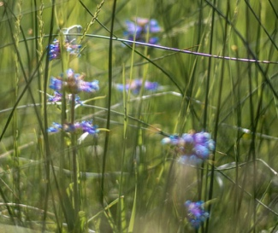

Ah. Such thanks for your interest in your Inner Elder.
Turning within for guidance is the antidote to the troubles of our world.
Below, I’m sharing two excerpts from Dare to be Old, a book in preparation.
A brief sneak peek into the wonders sustaining the Inner Elder in each of us.
.
Also, visit https://fullecology.com/inner-elder/to learn more about free introductions
and small-group courses available to help you nurture your relationship
with this profound aspect of your personality.

In This, ~Mary

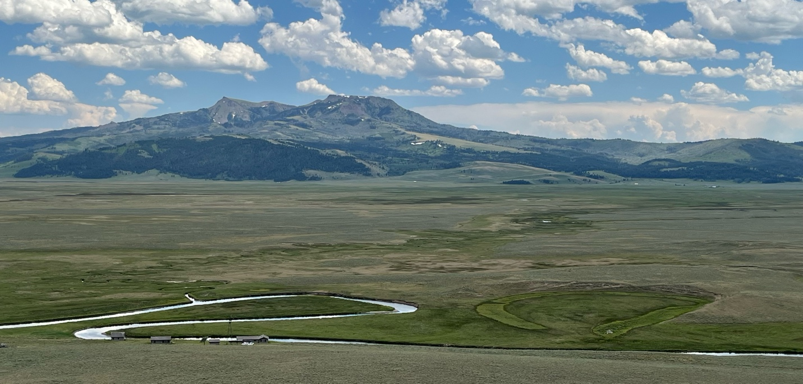

Dare to be Old
Embracing the Inner Elder No Matter Your Age

Mary M Clare

~EXCERPTS~

Prelude: Showing up
Once upon a time, here on Earth, there was a magnificent burst of heat. The heat was so extreme, it melted rock to run as freely as water. The molten rock ran underground, moving like flood waters, gaining speed until it reached a wall of stronger rock with a higher melting point – a wall so mighty that the melted rock had no choice but to pile up on itself, eventually bursting through the ceiling to explode the seams of our Earth in a fiery fountain. Over time, it would cool to become the planet’s newest surface.
In time these rocks and the oceans around the rocks became populated with microorganisms. Content to be at home in rock or in water, these microorganisms very … very … slowly, diversified. Over vast stretches of time, they became grasses and trees, fishes and birds, and finally, us.

Philosopher, physicist and spiritual leader A. H. Almaas refers to this unfolding as Holy Logic. A logic that unfolds perfectly with no plan, no apriority or strategic goal, and yet with meaning, and with ever increasing specialization and complexity. Quantum physicists and cosmological scientists are coming to understand the story of our universe as one among many, each with meaningful evolutionary systems consistent with what Almaas proposes. Unity appearing as diversity.
Our home universe began as a breath and continues now, 13.8 billion years later, on its path from origin, across purposeful and meaningful expansion into the complexity and diverse specialization we know in our world today. We breathe that original breath. We are that unity in diverse expression. A unification present and evident within and across all that is known - and unknown.

So, what is it in human experience that taps in, most cleanly, most directly, to this unified consciousness? Enter the Inner Elder – the aspect of personality that travels with each of us all along, never losing touch with the fact of being in and of the consciousness of stars. The Inner Elder is an intrapsychic companion that arrives in infancy with the dawning of self-awareness. (perception? awareness?) Once we’re able to know anything at all, the Inner Elder holds generously our capacity always to know the way. Leaning toward the best for the most, toward kindness, toward loving practicality, mutuality and divine humor.
We have entered the time of remembering. Of opening again to the ancient, deep knowing of our ancestors, of the planet, of the deep cosmos. Your Inner Elder remains right here, ready to accompany you, ready as your trusted companion and guide.
The Story of How Mary Found her own Inner Elder

The Inner Elder holds the experience of being in synch with our truest nature. In this, we know complete belonging. The Inner Elder is the lifelong companion who can be relied upon to remind us of this core, this integrity, this belonging.
So how do you meet your Inner Elder in the first place? Here’s the story of how I came to see her for the first time.

In the early 90’s, I had a friend – Arleta. We met when she agreed to be an adjunct instructor for a graduate program I directed. She was accomplished with psychometrics – able to teach tests & measurements, intellectual, academic, socio-emotional. I’d never warmed to the topic myself, so I was endlessly grateful to have Arleta bring her enthusiasm and considerable skill to the task.

Arleta was about seven years older than I. She had a doctorate in the social sciences from a sophisticated east coast university. In the very early 70’s she’d worked at with Saul Alinsky. Alinsky wrote the book Rules for Radicals and was a vital community organizer in Chicago advocating fiercely and to good effect for the interests of poor and unhoused people and others systematically subjected to social injustice.

Arleta had that fire, even as she worked in systems as seemingly steeped in dominant culture as psychological tests and measurements. She understood the assessment strategies not as the truth, but as tools, offering her students ways of using these tools to advocate for children, youth and families in schools.

One day, I had arranged to take a stack of course materials by Arleta’s suburban home. She greeted me at the door of the single level ranch-style house and ushered me through the long entry hall back to the kitchen table. We stood and talked for a bit, reviewing what I’d just brought. As she was showing me out, Arleta gestured to the slatted accordion fold doors of the hallway closet. “That’s where I go when I need to call a meeting.” “Oh,” I said. “A meeting?”

Arleta had told me the first day we met that she lived what we now call Dissociative Identity Disorder - back then referred to as Multiple Personality Disorder. “Yeah,” she went on. “When things are getting a little disorganized, I just turn inward and say, ‘Ok, everybody. In the closet. Time to chat.’ We go in there, close the door, sit in a circle, and listen all around until we know how everyone is and what they need.” She opened the front door to guide me outside. “It works really well.”

I admired Arleta’s courage and matter-of-fact honesty as much as I was awed by her intelligence and skill. As I started the car to head home, I found myself thinking of the parts that compose who I am at any given time. Like most of us, I’m not challenged with parts of my personality taking charge and leaving everyone else asleep while they venture out solo, sometimes in dangerous ways. Nonetheless, I was quickly able to discern the parts of me that were right there in my consciousness on that drive. Of course, there was the professor – the executive who kept everything in order. There was the drill sergeant, the ingenue, the wild child, the frightened little girl, the obsessively nerdy tween. The list goes on. But over in the corner, comfortable on an overstuffed ottoman, was an old woman in a billowing skirt, soft and covering her shoes. As she sat, she smiled, shaking her head from time to time with bemusement as if she were saying, “Oh you dears. You’re so entertaining to watch.” No one minded, yet everyone knew that she was the one who would let us know if any of us were off the mark or in danger. She was the one we could turn to for deepest comfort, for wisdom – for a reliable sense of belonging, of relevance. And we could be fully reassured that she’d let us know if there was ever any clear and present need to panic. There never was.

This is the Inner Elder. This old woman sitting on an ottoman in the corner of my being is my Inner Elder. You have one, too. A constant presence, not just in adulthood but from the moment of your birth. Curious, isn’t it, that no one ever told you of this aspect of your personhood – likely because they’d never been told either. Your Inner Elder – powerful, personal, loving and present – a guide and comfort across the whole of a lifetime.

